Hydrogen Line Telescope

Warren Herrington, Johanna Hein

**Subsystem Reports**

DRAFT REVISION

30th November 2021

Subsystem Reports

for

Hydrogen Line Telescope

Prepared by:

_____________________________

Author Date

Approved by:

_____________________________

Project Leader Date

_____________________________

John Lusher, P.E. Date

_____________________________

T/A Date

**Change Record**

|  |  |  |  |  |
| --- | --- | --- | --- | --- |
| **Rev.** | **Date** | **Originator** | **Approvals** | **Description** |
| **-** | 11/30/2021 | Team 10 |  | Final Report 403 – Subsystem Report |

Table of Contents

Table of Contents III

List of Tables

List of Figures

1. Introduction 1

2. Antenna Subsystem 1

2.1. Subsystem Introduction 1

2.2. Subsystem Details 1

2.3. Subsystem Validation 2

2.4. Subsystem Conclusion 4

3. Motorized Mount Subsystem 4

3.1. Subsystem Introduction 4

3.2. Subsystem Details 4

3.3. Subsystem Validation 5

3.4. Subsystem Conclusion 5

4. Route Planning Subsystem

4.1. Subsystem Introduction

4.2. Subsystem Details 6

4.3. Subsystem Validation 6

4.4. Subsystem Conclusion 7

5. Signal Processing Subsystem

5.1. Subsystem Introduction

5.2. Subsystem Details

5.3. Subsystem Validation 8

5.4. Subsystem Conclusion 12

6. Image Processing Subsystem 12

6.1. Subsystem Introduction 12

6.2. Subsystem Details

6.3. Subsystem Validation

6.4. Subsystem Conclusion

7. Graphical User Interface Subsystem

7.1. Subsystem Introduction

7.2. Subsystem Details 15

7.3. Subsystem Validation

7.4. Subsystem Conclusion

8. Appendix 19

List of Tables

Table 1: Route Planning Validation 2-D Area 7

Table 2: Route Planning Validation 2-D Terrestrial 7

Table 3: Route Planning Validation 1-D Terrestrial & RPA 7

Table 4: Signal Processing Validation 9

Table 5: Image Processing Validation 13

Table 6: GUI Validation 16

List of Figures

Figure 1: Antenna Validation Design & Construction 2

Figure 2: Antenna Validation Baseline Reading 3

Figure 3: Antenna Validation Milky Way Reading 3

Figure 4: Motorized Mount Validation 5

Figure 5: SDRSharp Signal, 1.2GHz Center Frequency 9

Figure 6: Signal Validation Test #1

Figure 7: Signal Validation Test #2 10

Figure 8: Signal Validation Test #3

Figure 9: Signal Validation Test #4 11

Figure 10: Signal Validation Test #5

Figure 11: Image Validation 2-D Selection

Figure 12: Image Validation 2-D Terrestrial Sweep 14

Figure 13: Image Validation 1-D Terrestrial Sweep / RPA 14

Figure 14: GUI Mode Selection

Figure 15: GUI 2-D Area Selection 17

Figure 16: GUI 2-D Terrestrial Sweep

Figure 17: GUI 1-D Terrestrial Sweep 18

Figure 18: GUI RPA

# Introduction

This report gives an overview of all subsystems within the HLT project. This project has a total of six subsystems. The antenna, motorized mount, and route planning subsystems were completed by Warren Herrington while the signal processing, image processing and GUI subsystems were completed by Johanna Hein. All electrical components have been completed for the six subsystems along with all validation that can be completed before integration. The outcome of each subsystem as well as the completed validation are detailed in the following sections.

# Antenna Subsystem

## Subsystem Introduction

This subsystem's purpose is to detect microwave emissions from hydrogen in our galaxy. To complete this task this subsystem will be tuned for 1420 MHz and have a HPBW of 10 degrees. The antenna’s data will be read by the SDR in the full system.

## Subsystem Details

There are many different antenna designs that were looked at but all had different issues. Parabolic antennas have very narrow beamwidths however manufacturing is difficult at best and probably infeasible with the resources available. A Yagi-Uda antenna can also provide narrow-beam widths however the spacing on the antenna is extremely precise and would take meters of length to get to the required beamwidth. Given the alternatives, a helical design was chosen for this project due to its dense design, forgiving characteristic, and relative ease to achieve narrow beamwidths.

To meet the specifications of this project, a four-element helix array was chosen. Each element has twenty-two turns so that when combined in the array it has a calculated HPBW of 10 degrees. The circumference of the array is equal to the wavelength of light we are trying to measure to put it into axial mode. The spacing is 4.55 centimeters between each turn to maximize gain. Each element is then spaced at 2.236 times the desired wavelength. This design was then modeled and simulated in MATLAB’s Antenna Designer.

Once the model met the desired characteristics, the next step involved the development of the building process. To make for easier manufacturing, the design changed from a circular helix to a square helix as this makes very little difference in the final gain. Next, the system was designed in AutoCAD so that the frame for the elements could be laser cut out of acrylic. Once the designs were developed and finalized, the acrylic pieces were cut out and glued together using epoxy. Then 10-gauge copper wire was wrapped around each acrylic skeleton to produce each element.

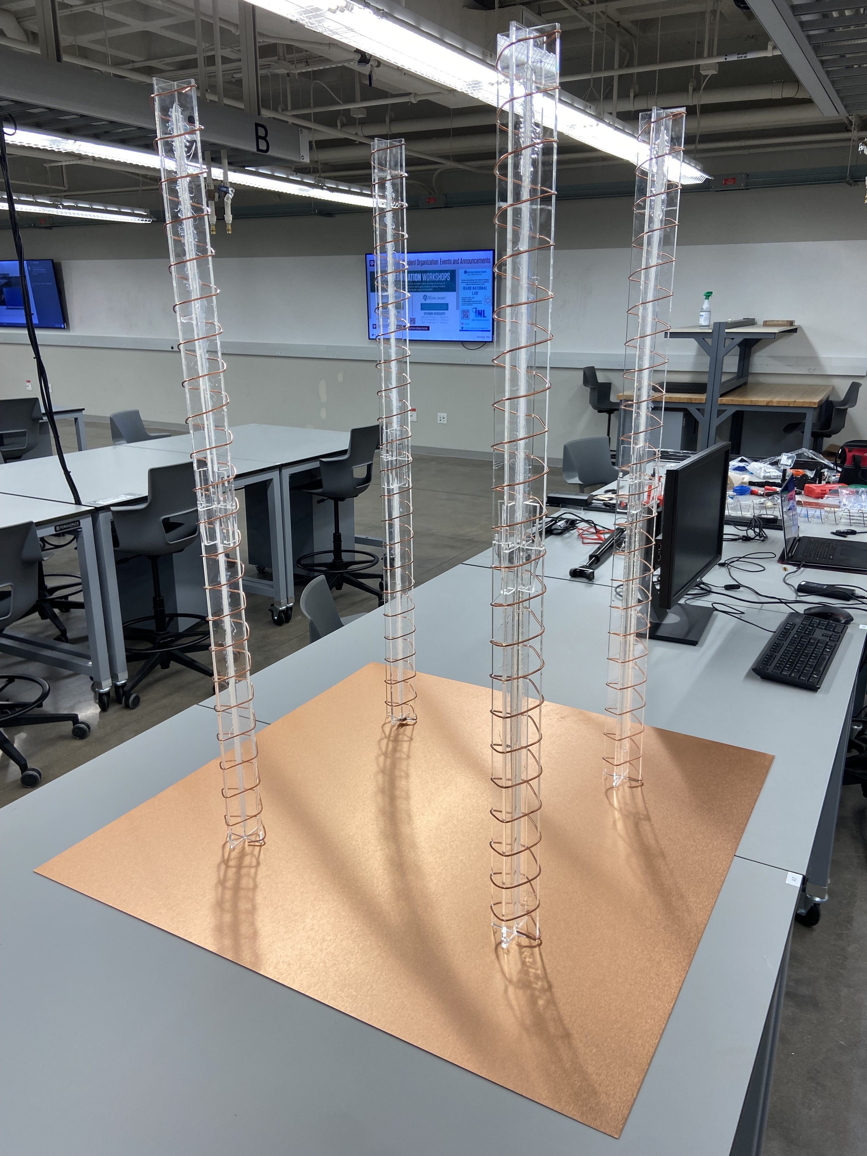

Figure : Antenna Validation Design & Construction

Each element will be impedance matched to the rest of the radio system using a copper triangle to reduce the 140 Ohm impedance of the antenna to the 50 Ohm used by the rest of the system. After an SMA connector is attached at the feed point of every antenna, a coax cable will feed each signal into a 4-way power combiner. The LNA will be placed directly at the output of the power combiner to lock in the signal to noise ratio. The output of the LNA will then feed into the SDR which is attached to the Raspberry Pi.

## Subsystem Validation

Initial progress has been made on the validation and more rigorous validation will follow once final construction is complete. A single antenna element was initially tested using references in the night sky to make sure that the expected signals were observed. Full testing will involve rigorous gain mapping of the completed array.

The initial testing was completed by pointing a single element at two parts of the sky and comparing the results. The first scanned section of the sky was relatively empty of celestial objects to get close to a baseline reading. The second scanned section of the sky was near the center of the Milky Way Galaxy. By comparing these results, we can see if there is any directionality to our antenna and whether or not it picks up the desired signal. In this initial test the results were exactly as expected.

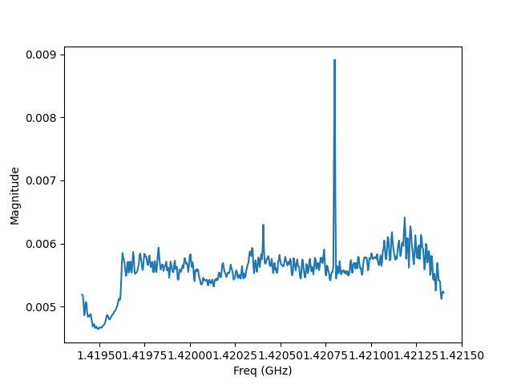

Figure : Antenna Validation Baseline Reading

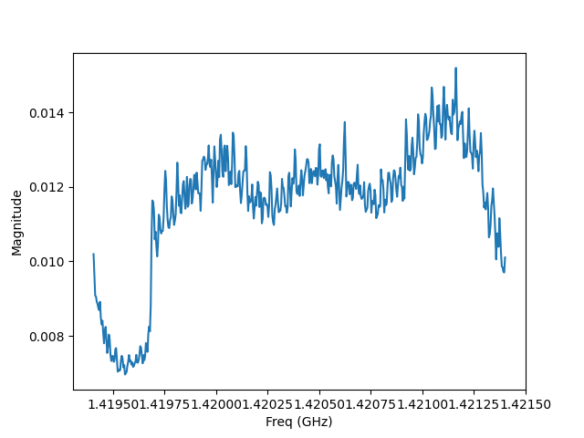

Figure : Antenna Validation Milky Way Reading

In the first figure there is very little signal just random noise with a peak magnitude of approximately 0.009. The second photo, however, shows three distinct humps. The leftmost hump comes from the hydrogen emission being redshifted as one of the arms of the galaxy moves away. The center hump comes from the center of the milky way which isn’t moving much compared to the antenna element’s reference and the rightmost hump comes from the blueshift of the arm that is moving towards the antenna. The peak magnitude in the second image is much higher at a value above 0.014.

## Subsystem Conclusion

The subsystem execution and validation goals were met this semester. Future work in this subsystem involves final assembly of the array and validation of that finalized system. Finalized assembly and integration with the mount will happen once school resumes in January. The antennas read the correct frequency with some directionality. The full array has not been assembled and the exact gain pattern needs to be mapped.

# Motorized Mount Subsystem

## Subsystem Introduction

The goal of this subsystem was to position the antenna array accurately and reliably where desired. The motorized mount will take the desired points given to it by the route planning subsystem and then position itself and the antenna at that point until given a new position.

## Subsystem Details

There are several different methods traditionally used for antenna positioning however the design used in this project took a different approach. Most antenna mounts use two rotational motors in order to position at the correct azimuth and elevation. This design has several issues that would have been difficult to overcome with the HLT project. This system works well with small antenna. However, with a large array, very large motors or sizable counterbalances would be needed to make this system work effectively. Also, true rotation was not needed as the main lobe of the HLT antenna is symmetrical. For the HLT project I designed a two DOF system inspired by recent progress in parallel robotics. The parallelized motorized mount has a simpler design only needing two linear actuators to achieve its movement as well as a much simpler control system. Initially a stepper motor design relying on positional mathematics and reverse kinematics was envisioned, however a simpler feedback loop was finally decided on due to its robustness and versatility.

The feedback system works by moving one linear axis until the accelerometer communicates that it is at an acceptable value. Then, the system moves the next axis to an accelerometer approved point. The linear actuators and accelerometer move in this way until both axes are at correct values. In order for this system to work, I had to derive a non-standard spherical coordinate system so that each axis could be individually mapped and confirmed. The route planning subsystem automatically converts to this coordinate system for ease of use.

## Subsystem Validation

As shown in the validation schedule, validation for this subsystem will be completed after final assembly. Initial values of the accelerometer appear correct but need to be thoroughly evaluated. The future validation plan is to request mount movement to a specific position and then check the error using an external digital level.

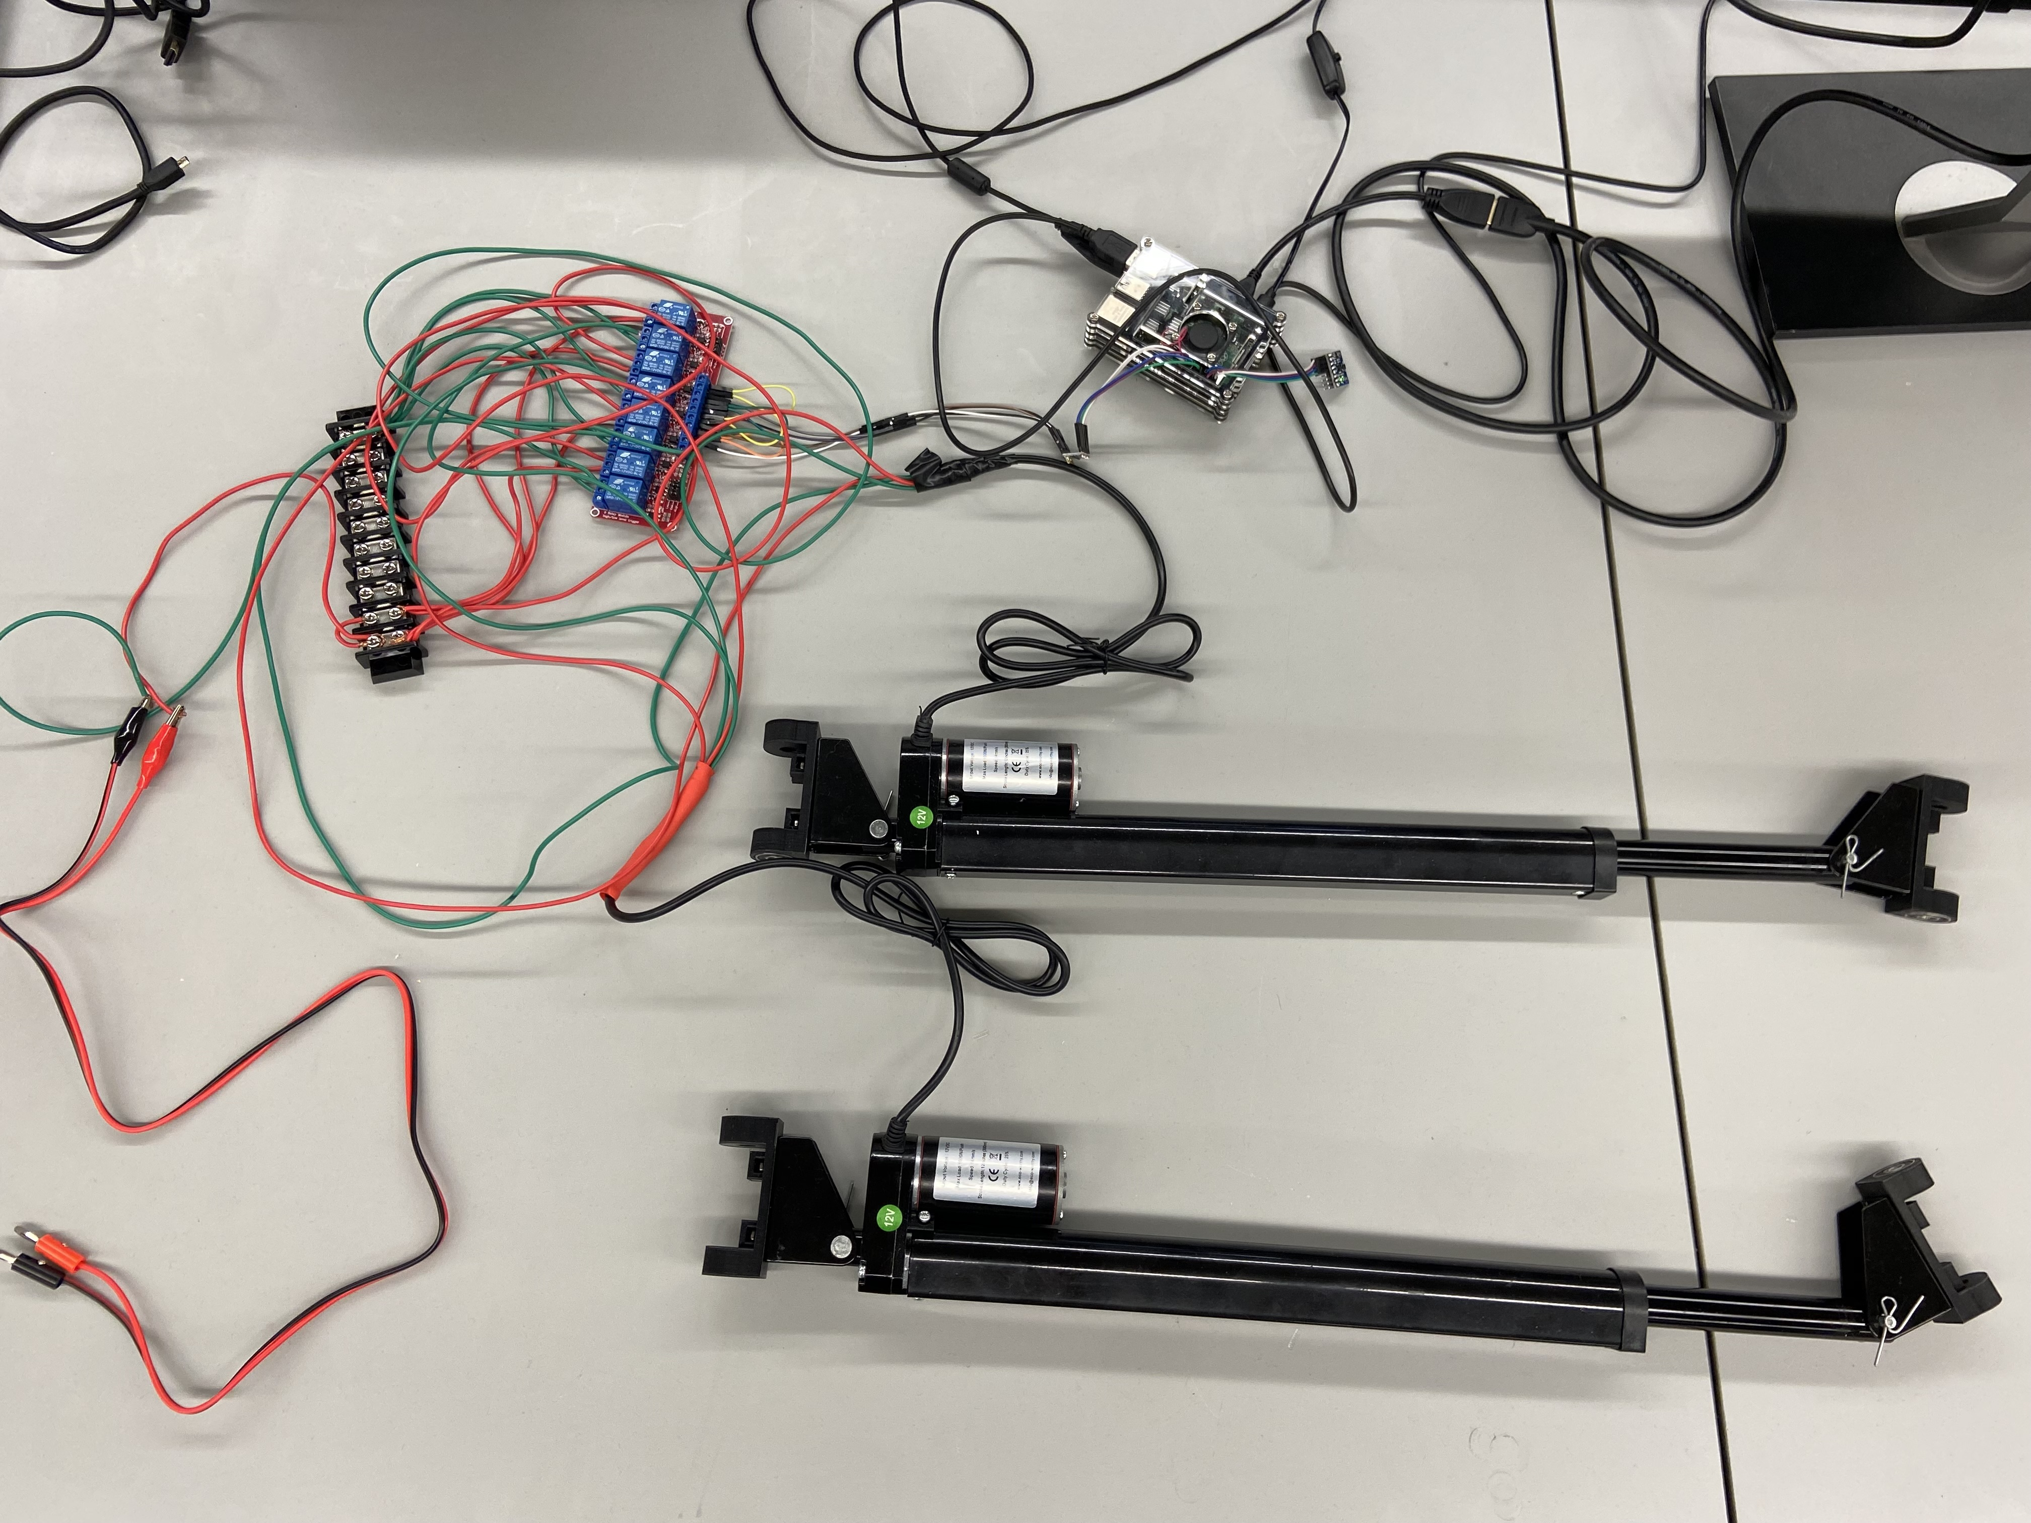

Figure : Motorized Mount Validation

## Subsystem Conclusion

This subsystem has a completed electronics system however the mechanical frame still needs to be assembled. The linear actuators and their control system have been built and tested. The final assembly of the frame will happen at the beginning of ECEN 404 during the integration phase.

# Route Planning Subsystem

## Subsystem Introduction

This subsystem's purpose is to plan all the individual points the antenna will scan in order to create the necessary image. It reads in different pixel-based coordinates based on what mode the user selects and then plans all the necessary steps.

## Subsystem Details

The subsystem reads in the pixel radius of the image and the pixel coordinates selected by the user with the center of the photo as the origin. Based on what the program needs for each mode, the script extrapolates and transforms the different positions.

The two-dimensional area scan takes in two inputs containing the coordinates of diagonal rectangle corners. First, the program extrapolates all additional points based on the HPBW and the two input points. The route planner then feeds this list of points to the heart of the program, the projection mapper. The projection mapper converts the given points from the equal area projection to the spherical coordinate system used by the motorized mount. The program starts by normalizing the points according to their maximum radius. It then converts from 2-D Cartesian points to 2-D polar points. Using these polar points, the program converts to spherical coordinates using the standard inverse projection mapping for the equal area projection used in this project. Then the route planner uses a conversion equation to map the spherical projection into one that instead uses two-phi values. These final phi values are then output as a list to be delivered to the Raspberry Pi.

Two-dimensional terrestrial sweep uses a similar method but only generates points for a single axis. Both one dimensional terrestrial sweep and repeated point analysis use the inverse projection to output a single point.

## Subsystem Validation

This subsystem was validated by feeding in sample coordinates from the GUI subsystem and confirming the positioning output by the route planner. These tests were completed several times with a variety of input points so that the correct values were verified to be consistent. Example data for each mode of coordinate selection is shown below.

|  |  |  |  |  |  |  |  |  |  |  |  |  |  |
| --- | --- | --- | --- | --- | --- | --- | --- | --- | --- | --- | --- | --- | --- |
| Phi x | Phi y | Phi x | Phi y | Phi x | Phi y | Phi x | Phi y | Phi x | Phi y | Phi x | Phi y | Phi x | Phi y |
| -37 | -23 | -28 | -22 | -20 | -21 | -11 | -20 | -3 | -20 | 5 | -20 | 14 | -20 |
| -36 | -14 | -27 | -13 | -19 | -12 | -11 | -12 | -3 | -12 | 5 | -12 | 13 | -12 |
| -35 | -5 | -27 | -4 | -19 | -4 | -11 | -4 | -3 | -4 | 5 | -4 | 13 | -4 |
| -35 | 5 | -27 | 5 | -19 | 4 | -11 | 4 | -3 | 4 | 5 | 4 | 13 | 4 |
| -36 | 14 | -27 | 14 | -19 | 13 | -11 | 13 | -3 | 12 | 5 | 12 | 13 | 13 |
| -37 | 24 | -28 | 22 | -20 | 21 | -12 | 21 | -3 | 20 | 5 | 20 | 14 | 21 |
| -39 | 33 | -30 | 31 | -21 | 30 | -12 | 29 | -3 | 29 | 6 | 29 | 14 | 29 |
| -41 | 43 | -32 | 40 | -22 | 38 | -13 | 37 | -4 | 37 | 6 | 37 | 15 | 38 |
| -45 | 52 | -35 | 49 | -25 | 47 | -14 | 46 | -4 | 46 | 7 | 46 | 17 | 46 |

Table : Route Planning Validation 2-D Area

|  |  |
| --- | --- |
| Phi x | Phi y |
| -64 | 73 |
| -54 | 60 |
| -47 | 48 |
| -43 | 37 |
| -41 | 25 |
| -39 | 13 |
| -39 | 2 |
| -39 | -10 |
| -40 | -21 |
| -42 | -33 |
| -46 | -45 |
| -51 | -56 |
| -60 | -69 |

Table : Route Planning Validation 2-D Terrestrial

|  |  |
| --- | --- |
| Phi x | Phi y |
| 31 | 17 |

Table : Route Planning Validation 1-D Terrestrial & RPA

## Subsystem Conclusion

This subsystem is already integrated with the GUI and works for all modes. Future work in this subsystem involves implementing earth’s rotation in the output positional data. This feature will be added during integration after the time for each antenna scan is determined.

# Signal Processing Subsystem

## Subsystem Introduction

The goal for this subsystem is to successfully pull raw data from the desired SDR at the selected center frequency through Python, graph the raw data to confirm results, and output the peak magnitude and frequency of that data in CSV files. In the final integrated system, the peak magnitude and frequency value for each antenna scan will be added to these CSV files and sent to the image processing software to create heatmaps.

## Subsystem Details

The signal processing subsystem uses the soapy power library in Python to communicate with an SDR. The soapy power library has a number of settings to customize the signal acquisition. This signal processing script uses several including defining the correct driver, defining the center frequency, outputting the raw data to a CSV file, specifying the desired gain, cropping the raw data as needed to remove soapy power artifacts, and averaging several spectra of data to output more accurate results.

The signal processing script also converts the magnitudes output by the soapy power module into linear values. From these values, the script pulls the peak magnitude and the frequency at that magnitude and outputs these values to separate CSV files. These CSV files will be sent to the image processing software after integration to create heatmaps of the data.

The final SDR used in this project will be the Airspy Mini SDR, however, the Airspy Mini experienced some technical difficulties due to product malfunction. So, an RTL-SDR was used for the final subsystem demo for ECEN 403. The RTL-SDR is a much cheaper SDR and, as expected, the signal data acquired by this SDR shows much more noise.

## Subsystem Validation

The validation for this subsystem is in progress and will be completed during subsystem integration. The signal processing program was tested with a RTL-SDR to confirm successful data pulling, accurate raw data, and correct peak frequency and magnitude values calculated from the data.

The accuracy of the raw data was determined by comparing the signal processing program output to results in SDRSharp which is the program maintained by Airspy for SDR signal viewing.

These tests were completed with the RTL-SDR and the first test antenna with a center frequency of 1.2Ghz. The series of five tests was taken over a period of 30 minutes in the FEDC. The validation requirements show that the system must have an inaccuracy rate less than 30%. These test results show an accuracy rate of 100% or an inaccuracy rate of 0%.

|  |  |  |  |  |
| --- | --- | --- | --- | --- |
| **Test Number** | **Successfully Pulled Data** | **Confirm Data Accuracy** | **Output Correct Magnitude** | **Output Correct Frequency** |
| **Test #1** | PASS | PASS | PASS | PASS |
| **Test #2** | PASS | PASS | PASS | PASS |
| **Test #3** | PASS | PASS | PASS | PASS |
| **Test #4** | PASS | PASS | PASS | PASS |
| **Test #5** | PASS | PASS | PASS | PASS |

Table : Signal Processing Validation

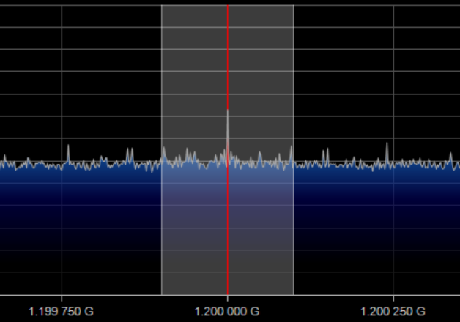

Figure : SDRSharp Signal, 1.2GHz Center Frequency

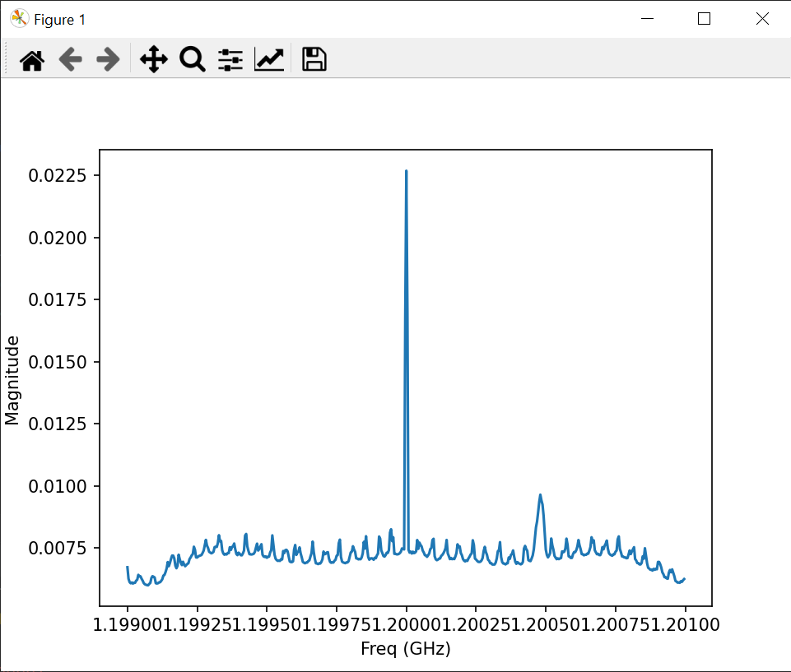

Figure : Signal Validation Test #1

*Magnitude: 0.02269, Frequency: 1.2 GHz*

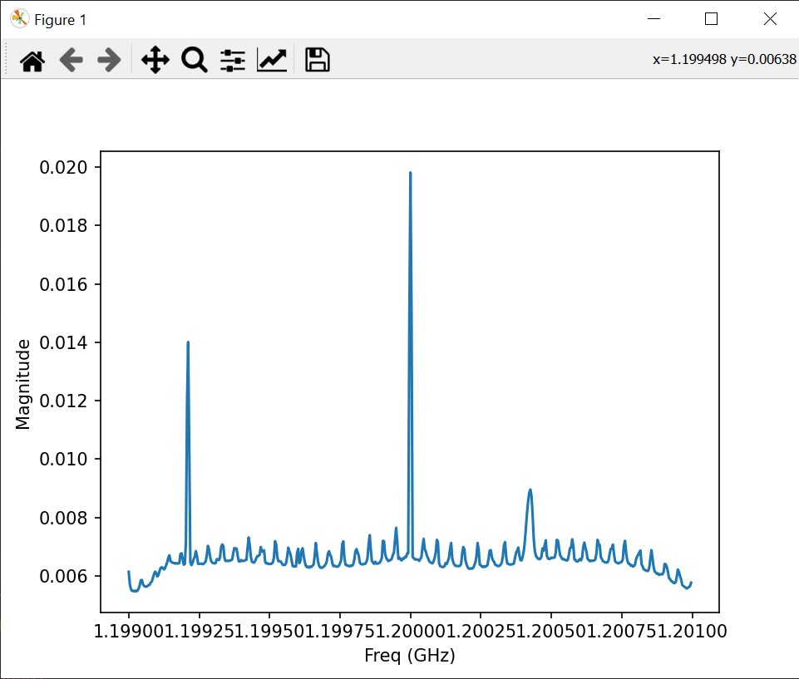

Figure : Signal Validation Test #2

*Magnitude: 0.01981, Frequency: 1.2 GHz*

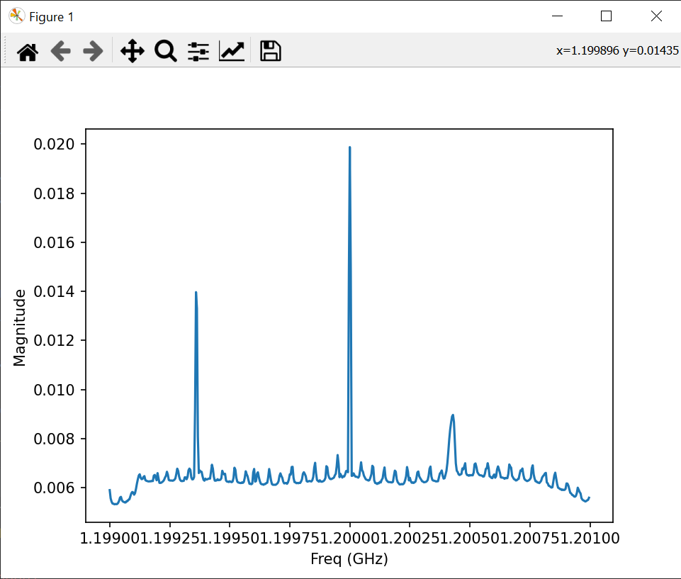

Figure : Signal Validation Test #3

*Magnitude: 0.01988, Frequency: 1.2 GHz*

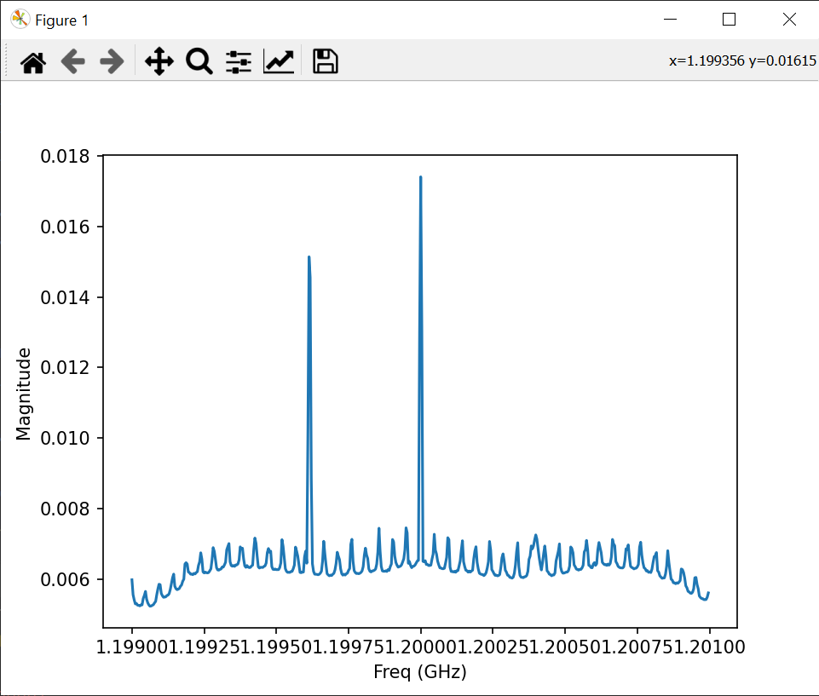

Figure : Signal Validation Test #4

*Magnitude: 0.01740, Frequency: 1.2 GHz*

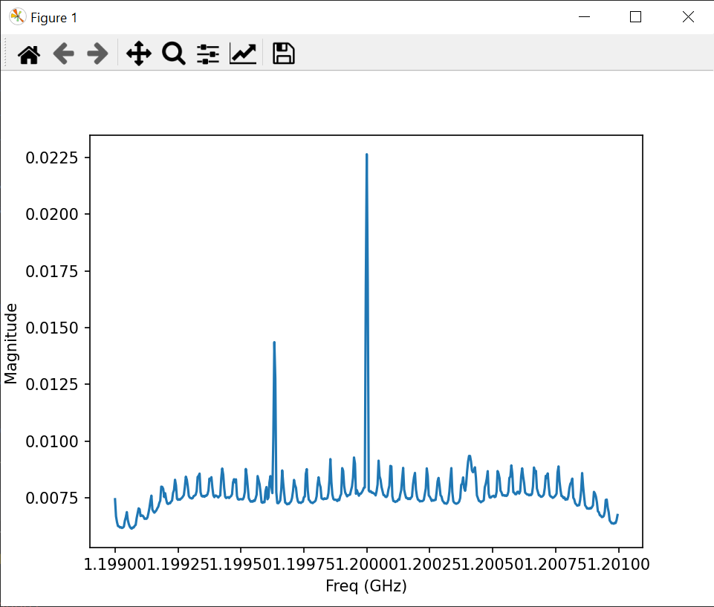

Figure : Signal Validation Test #5

*Magnitude: 0.02264, Frequency: 1.2 GHz*

Further testing for this subsystem includes testing a working Airspy Mini SDR and the first test antenna at 1.2GHz, the Airspy Mini SDR with a single antenna element at 1.42GHz, and the Airspy Mini SDR with the complete antenna array at 1.42GHz. These additional tests will be completed during the integration stages in ECEN 404.

## Subsystem Conclusion

All execution goals for this subsystem were completed during this past semester. The Airspy Mini will be repaired or reordered over the winter break, and this subsystem will be ready for integration and completed validation tests in the Spring.

# Image Processing Subsystem

## Subsystem Introduction

This subsystem focuses on taking in CSV files from the signal processing subsystem and converting those CSV files into heatmaps. These heatmaps will be overlaid on Skymap photos of the scanned area, this final image will be output to the user as the final result of the scan. The image overlaying and output to the user will be completed in ECEN 404 during the integration stage.

## Subsystem Details

The image processing subsystem was also written in Python and makes use of the pandas and matplotlib pyplot libraries. The heatmaps are created based on a color scheme consisting of two colors, red & blue. These colors were chosen to represent the doppler shift of the object the antenna is scanning. In the heatmaps, any frequency values less than the center frequency of 1.420405GHz are assigned to the color red while any frequency values greater or equal to the center frequency of 1.420405GHz are assigned to the color blue. The red values indicate objects that are moving away from the antenna and the blue values indicate objects that are moving towards the antenna.

Once each frequency value in the heatmap is assigned to either red or blue, the intensity of each pixel is adjusted with the magnitude of the signal at each data point. The largest magnitude receives the highest intensity and vice versa. Finally, the individual pixels are interpolated to create a cohesive heatmap.

## Subsystem Validation

This subsystem was tested and validated by creating randomized data for each mode of telescope operation. This data containing peak magnitudes and the corresponding frequencies, was saved in CSV files to emulate the input files that will eventually be used for this subsystem. Those CSV files were then fed into the appropriate function in the image processing script to produce heatmaps for each mode of operation.

The modes of operation output for testing and validation consist of 2-dimensional area selection, 2-dimensional terrestrial sweep, 1-dimensional terrestrial sweep, and repeated point analysis. A total of five tests were completed to determine image processing accuracy with different randomized data created for each test. The tests passed if the raw data input to the image processing software matched the corresponding heatmap output.

|  |  |  |  |
| --- | --- | --- | --- |
| **Test Number** | **Successfully Imported Data** | **Output Correct Doppler Shift** | **Output Correct Intensity** |
| **Test #1** | PASS | PASS | PASS |
| **Test #2** | PASS | PASS | PASS |
| **Test #3** | PASS | PASS | PASS |
| **Test #4** | PASS | PASS | PASS |
| **Test #5** | PASS | PASS | PASS |

Table : Image Processing Validation

The 2-D selection mode outputs a rectangular heatmap. The 2-D terrestrial sweep mode outputs a series of heatmaps lines, these lines will be output over the corresponding Skymap image in a GIF format. Similarly, the 1-D terrestrial sweep and RPA modes output a single pixel heatmap that will be overlaid on corresponding Skymap images and output in a GIF format.

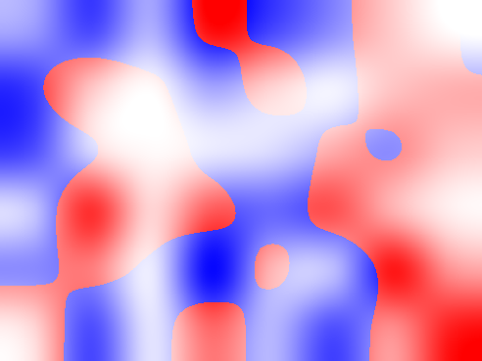

Figure : Image Validation 2-D Selection

    

Figure : Image Validation 2-D Terrestrial Sweep



Figure : Image Validation 1-D Terrestrial Sweep / RPA

## Subsystem Conclusion

The validation and execution for the image processing subsystem is complete. Future work in this subsystem involves integration with the signal processing subsystem in order to output heatmaps for real time data and merging the heatmaps with Skymap screenshots.

# Graphical User Interface Subsystem

## Subsystem Introduction

The graphical user interface (GUI) subsystem allows the user to select their desired scanning mode and determine the scanning coordinates and duration. The goal for this subsystem is to create a simple and easy to understand design with clear instructions for the user included for each mode of operation.

## Subsystem Details

This subsystem makes use of the tkinter Python library for GUI development. The subsystem also accesses Stellarium’s API to take a current screenshot of the atmosphere every time the GUI runs. The Stellarium screenshot is customized for the purpose of this project by adjusting Stellarium’s field of view, showing the azimuthal grid, adjusting the view to the current date, time, and location, and setting the zoom level. The projection method chosen in Stellarium is the Lambert Azimuthal Equal-Area projection as this projection style fits well with the scope of this project.

After the real-time Skymap screenshot is procured from Stellarium, this screenshot is sent through a few cropping functions. These functions crop the image to specific image dimensions and create a circular image that is adjusted so that the user can only select within the range of the antenna. This final circular image is displayed in each GUI coordinate selection window.

The Skymap coordinates are chosen by the user after they click the “Select Corners” or “Select Point” button within each mode. As stated in each mode’s instructions, after this button is selected, the program will start recording mouse click coordinates within the Skymap image. These coordinates are normalized to an x-y coordinate system with the origin at the center of the Skymap and display below the Skymap after selection. The program only allows the user to select the proper number of coordinates based off of the chosen mode.

When the user selects the “Initiate Scan” button, the GUI sends the selected coordinate(s) directly to the route planning subsystem. The GUI and route planning subsystems are already completely integrated.

## Subsystem Validation

This validation for this subsystem involved interacting with a potential user of this product. The user interacted with the GUI after 3 minutes of instruction. The user then rated each category of the GUI based off of their experience. The categories included design, instruction clarity, and ease of use.

The user chosen for this review was a sophomore electrical engineering student and fits the profile for future users of this product. The three minutes of instruction involved explaining the project concept to the user so that they could understand the reasoning behind the mode, coordinates, and duration selections. After the user interacted freely with the GUI, they were left to fill out the review form shown below. A rating of 1 indicates a need for significant improvement while a rating of 10 indicates that no improvements are needed. The GUI received an overall grade of 97.5%. Images of the GUI mode selection window and the coordinates selection windows are also shown below.

|  |  |  |
| --- | --- | --- |
| **Category:** | **Rating:** | **Comments:** |
| Design | 10 | Design is basic but straightforward and fulfills its requirement. |
| Instruction Clarity | 9 | Instructions were clear and concise, but some required inputs weren't clearly marked such as the time and could use additional surrounding explanation. |
| Ease of Use | 10 | Easy to use and navigate |
| Cool Factor | 10 | Very cool Kanye |
| Total | 39 |  |
| Max possible score | 40 |  |

Table : GUI Validation

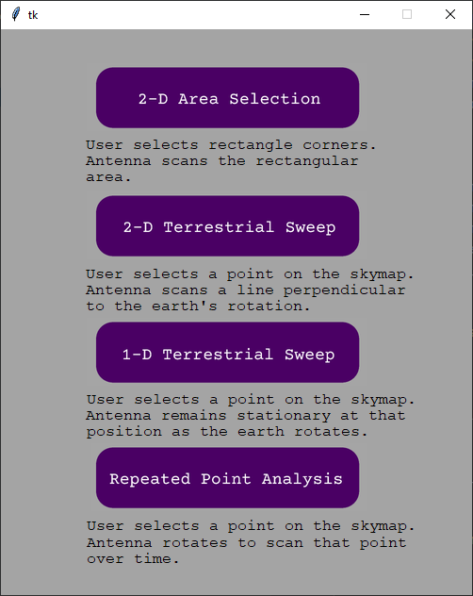

Figure : GUI Mode Selection

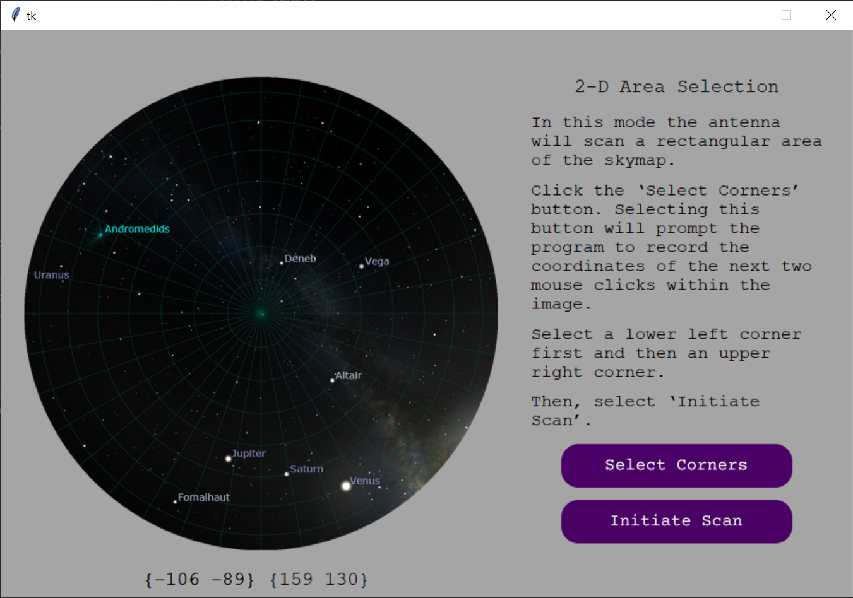

Figure : GUI 2-D Area Selection

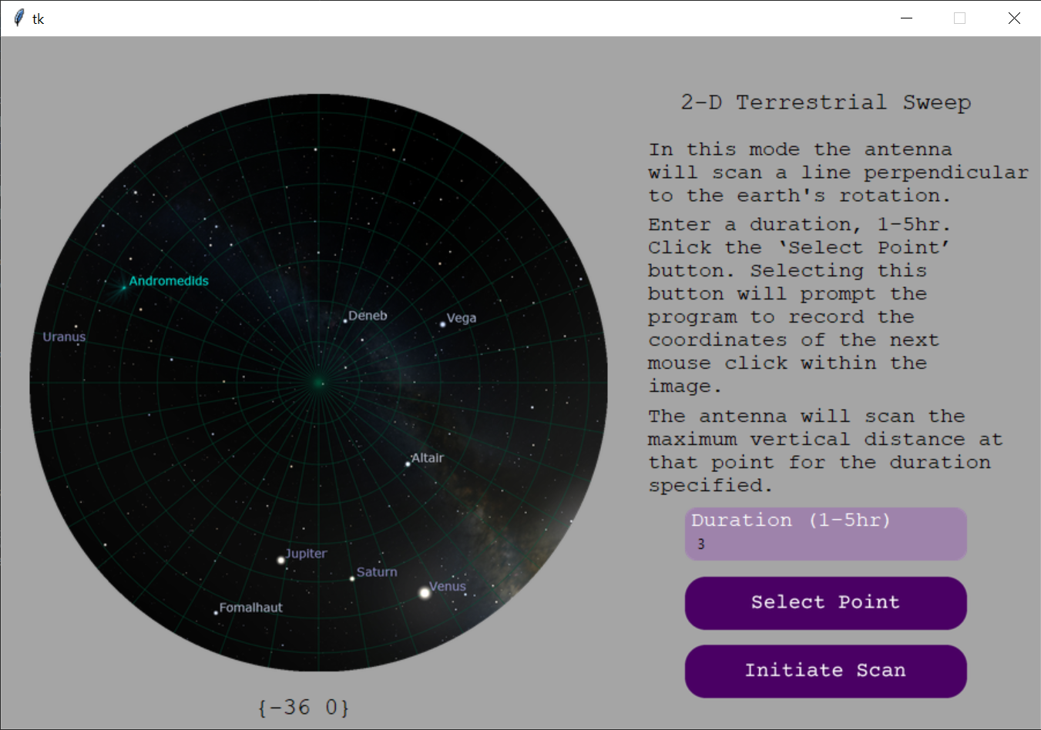

Figure : GUI 2-D Terrestrial Sweep

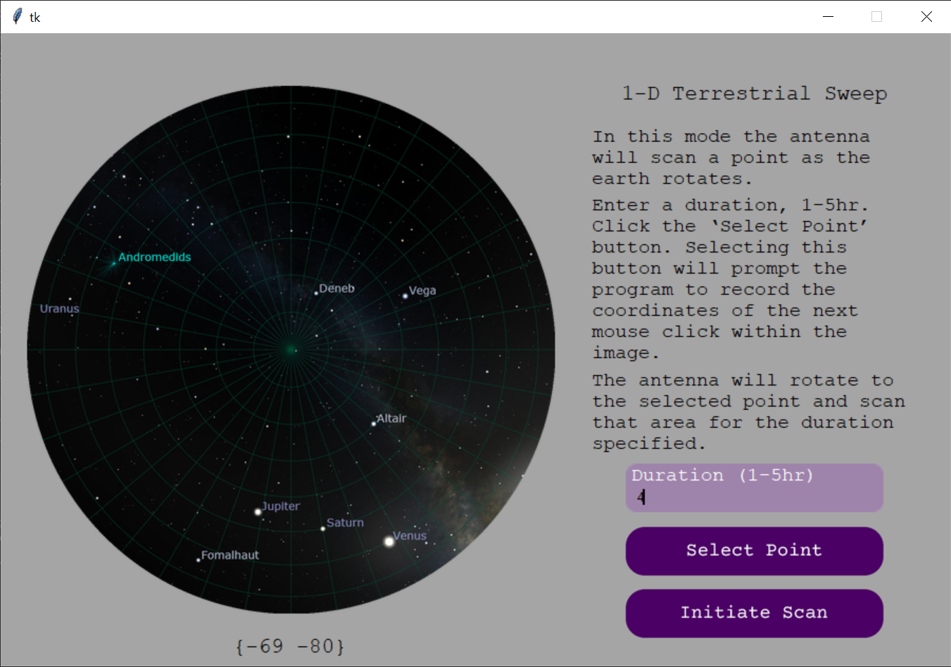

Figure : GUI 1-D Terrestrial Sweep

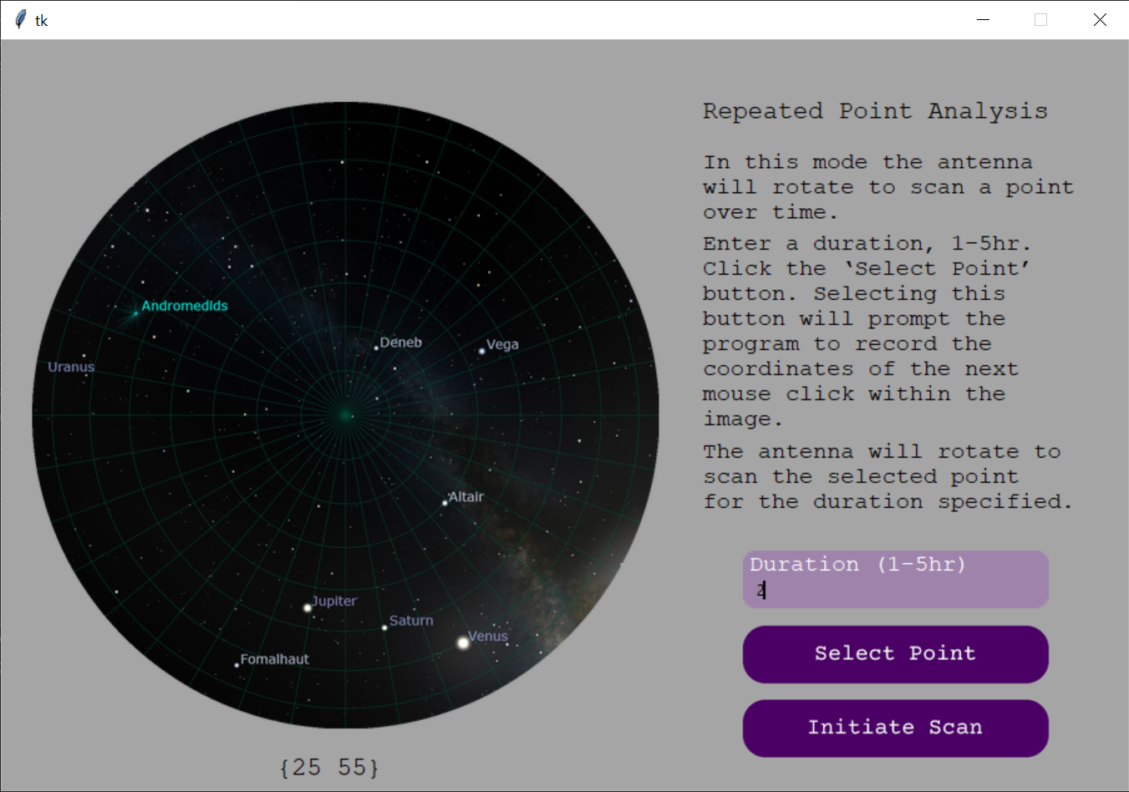

Figure : GUI RPA

Given the user’s feedback, several changes were made to the GUI to improve the user experience. The first change involved adding a description of the duration textbox for three of the scanning modes. The second change added display to show the coordinate values to the user after selection from the Skymap.

## Subsystem Conclusion

All execution and validation goals were completed for the GUI subsystem. Future work in this subsystem includes adding an output GUI window that displays the final image or GIF overlay to the user after antenna scans are completed. This addition will be completed during the integration phase in ECEN 404.

# Appendix

The Python scripts for all software subsystems are in the GitHub link for this project below.

[GitHub - Hydrogen-Line-Telescope/HLT at Final_Report_Scripts](https://github.com/Hydrogen-Line-Telescope/HLT/tree/Final_Report_Scripts)